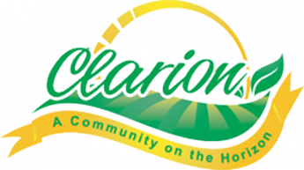
CITY OF CLARION
FAMILY $140.00
ADULT/YOUTH SINGLE $65.00
SENIOR (55+) $60.00
PUNCH CARD (10 PUNCHES) $45.00
DAILY PASS $ 4.50
3 AND UNDER FREE

